**Testimonial: Lead Generation and Advertisement by Remote Expert Solutions**

At Remote Expert Solutions, we specialize in generating high-quality leads and crafting effective advertisements to help our clients grow their businesses. Here's how we successfully enhanced the lead generation and advertisement strategy for 3PL CSI, a prominent warehousing and 3PL prep services provider in the USA:

1. **Understanding the Business and Goals**: Our process began with a thorough understanding of 3PL CSI's business model, services, and target market. We identified their specific goals for lead generation and advertising to tailor our approach effectively.

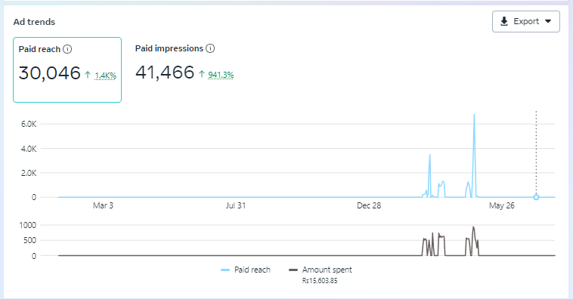

1. **Developing a Customized Strategy**: Based on our research, we designed a targeted lead generation and advertising strategy. This plan included identifying the right platforms, crafting compelling ad copy, and selecting visuals that resonate with the target audience.
2. **Creating Compelling Advertisements**: Our creative team developed eye-catching advertisements that effectively communicated 3PL CSI's value propositions. We used a mix of engaging graphics, persuasive text, and strong calls-to-action to capture the attention of potential clients
3. **Implementing Multi-Channel Campaigns**: We launched multi-channel advertising campaigns across various platforms, including social media, search engines, and industry-specific websites. This ensured maximum reach and exposure for 3PL CSI's services.
4. **Optimizing Campaign Performance**: By continuously monitoring campaign performance, we made data-driven adjustments to optimize ad spend and improve results. This involved A/B testing, audience segmentation, and refining ad copy and visuals based on performance metrics.We have gotten a significant number of leads in a very small budget.   
   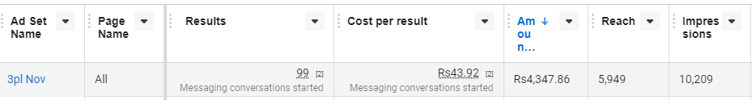
5. **Generating High-Quality Leads**: Our targeted approach resulted in a significant increase in high-quality leads for 3PL CSI. We ensured that the leads generated were not only numerous but also highly relevant and likely to convert into clients.  
   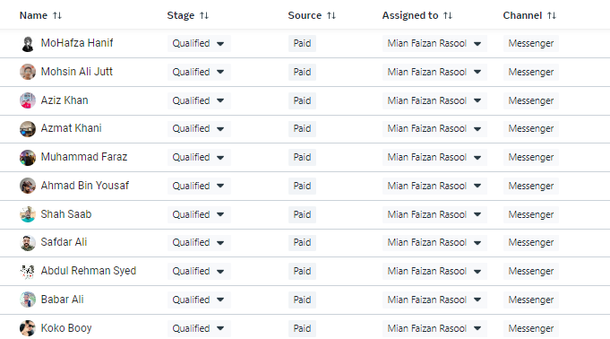

***You can see in the below screenshot that we have converted 130 leads into paying customers.***

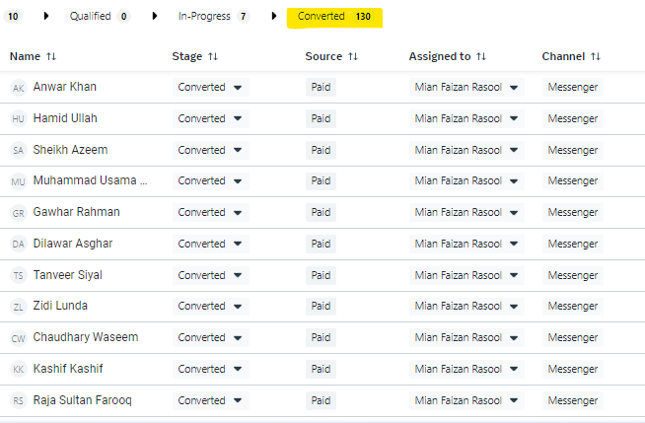

1. **Achieving Tangible Results**: The comprehensive lead generation and advertising strategy led to measurable growth for 3PL CSI. The enhanced visibility and increased inquiries translated into a higher client acquisition rate, boosting their overall business performance.

We are proud of the successful lead generation and advertising campaign we executed for 3PL CSI and look forward to helping more businesses achieve their growth objectives."